LFS|US Council Meeting
9th of January, 2023 // 5:00 PM // Michael Kingsmill Forum (Room 4301)

MEETING CALLED TO ORDER AT 5:08 PM
- Adoption of the previous agenda by Kaitlin, seconded by Ira
- Adoption of today’s agenda by Sarah , seconded by Ayasha
- LFS|US would like to acknowledge that we are meeting today on the traditional, ancestral, and unceded territory of the Musqueam people.

ATTENDEES

EXECUTIVE COUNCILLORS
Alisha Temirova  President  (she/her/hers) | P | Jade Permata  VP Academic  (she/her/hers) | P | Wyat Leung  VP Administration  (he/him/his) | P | Della Hamzah  VP Communications  (she/her/hers) | P
Sofia Faugno  VP External  (she/her/hers) | P | Tina Liu  VP Finance  (she/her/hers) | P | Jenny Kim  VP Internal  (she/her/hers) | P | Colette Kimura  VP Student Life  (She/Her/Hers) | P
Sondra Holleran  VP Engagement  (she/her/hers) | P | Melissa Marthias  Senior Advisor  (she/her/hers) | P | Cissy Zhang  AMS Representative  (she/her/hers) | E | Vivian Li  Student Senator  (she/her/hers) | P

COUNCILLORS
Academic Portfolio |  |  |  | Administration Portfolio
Levina Ira  AVP Academic  (she/her/hers) | P | Lucy Macdonell  APBI Representative  (she/her/hers) | E | Vincy Chuy Luo  Lounge & Apparel Coordinator  (she/her/hers) | p | Annie Yin  Governance Coordinator  (she/they) | P
Emily Ho  HEWE Coordinator  (she/her/hers) | P | Kaitlin Wong  FNH Representative  (she/her/hers) | P | Engagement Portfolio
Sophie Co  HEWE Coordinator  (she/her/hers) | E | Sylvia Fernandez  GRS Representative  (she/her/hers) | P | Nelson Fang  AVP Engagement  (he/him/his) | P | Vani Leung  EDI Coordinator  (she/her/hers) | E
Hannah Takasaki  HEWE Coordinator  (she/her/hers) | E | Chang Che  FRE Representative  (he/him/his) | P | Soyoung Jung  Sustainability Coordinator  (she/her/hers) | P | Lindsay Ilkay  EDI Coordinator  (she/her/hers) | E
 |  |  |  | Cynthia Agata Limantono  Sustainability Coordinator  (she/her/hers) | P | Ciarin Wrightson  WND Manager  (he/they) | p
Communications Portfolio |  |  |  |  |  | Macy Chen  WND Assistant Manager  (she/her/hers) | p
Clair Wang  AVP Communications  (she/her/hers) | P | Winnie Ng  Social Media Coordinator  (she/her/hers) | P | Internal Portfolio
Gayathri Sudeer  Graphic Designer  (she/they) | P | Hannah Reyes  Social Media Coordinator  (she/her/hers) | P | Pragti Varshney  AVP Internal  (she/her/hers) | P | Prudence Hung  Graduation Coordinator  (she/her/hers) | P
Masa Kono  Graphic Designer  (he/him/his) | P | Kalina Yu  Social Media Coordinator  (she/her/hers) | P | Elly Mok  Graduation Coordinator  (she/her/hers) | P | Amanda Xiao  First Year Representative  (she/her/hers) | P
Yu Xuan Ong  Graphic Designer  (she/her/hers) | P | Fatima Syahdella  Webmaster  (she/her/hers) | A | Ardelia Tjandra  First Year Representative  (she/her/hers) | P | Claire Chen  First Year Councilor  (she/her/hers) | A
Sarah Pham  Photographer  (she/her/hers) | P | Emily Wong  Photographer  (she/her/hers) | P | Rachel Lai  First Year Councilor  (she/her/hers) | A | Joyce Lau  First Year Councilor  (she/her/hers) | A
Finance Portfolio |  |  |  | Jason Lin  First Year Councilor  (he/him/his) | P | Justin Wibowo  First Year Councilor  (he/him/his) | P
Nadya Rei  AVP Finance  (she/her/hers) | P | Erin Kim  Finance Coordinator  (she/her/hers) | P | Esther Lin  First Year Councilor  (she/her/hers) | E | Jasmine Lam  First Year Councilor  (she/her/hers) | A

External Portfolio |  |  |  | Student Life Portfolio
Sara Escalante Fonseca  AVP External  (she/her/hers) | P | Rachel Fong  Partnerships & Student Benefits Coordinator  (she/her/hers) | P | Mandy Liu  AVP Student Life [Annual Events]  (she/her/hers) | E | Louistrycia Kho  AVP Student Life [Socials]  (she/her/hers) | E
Minal Nijhawan  Case Competition Coordinator  (she/her/hers) | P | Nikita Chanana  Partnerships & Student Benefits Coordinator  (she/her/hers) | E | Mohammad Ali  LFS Gala Coordinator  (he/him/his) | P | Wing Cheong  Social Coordinator  (she/her/hers) | P
Vanessa Arianto  Case Competition Coordinator  (she/her/hers) | P | Christella Khosasih  Partnerships & Student Benefits Coordinator  (she/her/hers) | P | Manny Mangat  LFS Gala Coordinator  (she/her/hers) | E | Nikita Li  Social Coordinator  (she/her/hers) | A
Payal Parti  Case Competition Coordinator  (she/her/hers) | P | May Wilsdon  Partnerships & Student Benefits Coordinator  (she/her/hers) | P | Trish Ma  LFS Week Coordinator  (she/her/hers) | E | Alex Shen  Athletic Coordinator  (he/him/his) | P
 |  |  |  | Beth Downie  LFS Week Coordinator  (she/her/hers) | P | Ayasha Santoso  Athletic Coordinator  (she/her/hers) | P

PRESENTATIONS
- Policies and Reminders
  - https://www.canva.com/design/DAFXKeUto_Y/yRwna8ziTOvufvMBAtweoQ/view?utm_content=DAFXKeUto_Y&utm_campaign=designshare&utm_medium=link2&utm_source=sharebutton
  - 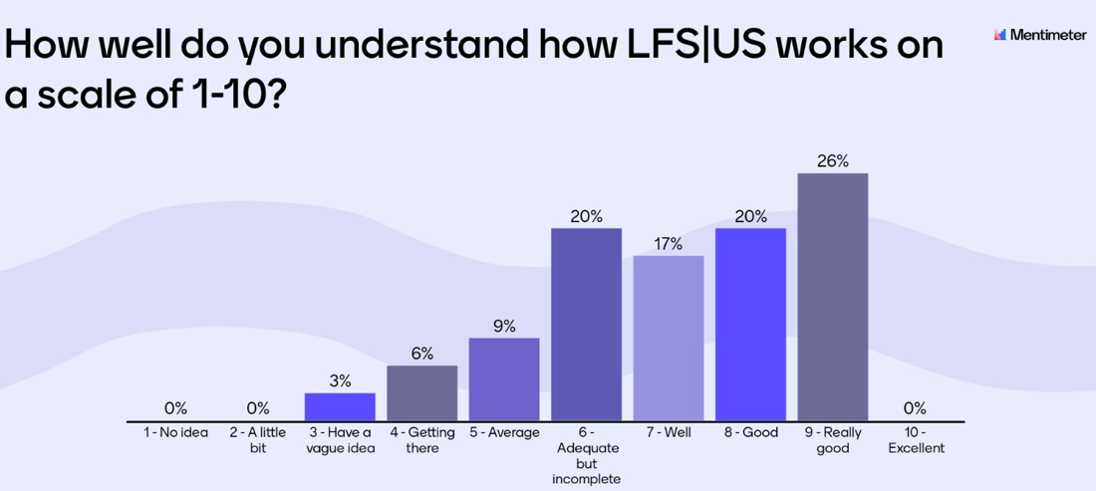
- Finance
  - How to get reimbursed & Finance recap for term 1
https://drive.google.com/file/d/1ceahOFMlFXA83q4P0p9TqGRA4dXXsBMv/view?usp=sharing
  - Credit Card Usage:
    - according to the new policies on the credit card, I will not be able to provide credit card information to other individuals. In this case, please provide a list/excel of items + quantity + links to purchase to my teams "tina6iu" message or email at "lfsus.vpfinance@gmail.com". Thanks everyone!

UPDATES
- President
  - Evangelos group photos deadline extended to Feb 28
  - Student Leadership Conference happening Jan 21
    - Check teams posts for more information.
  - Upcoming dates
    - Jan 16 Thilini Professional Development Workshop
    - Jan 23 (maybe) UBC Student Consultation Campus Vision 2050
    - March 27 AGM
- VP Academic
  - HEWE
    - Connecting with hewe in other undergrad societies to plan out interfaculty mental health week right now
  - Program Reps
    - Planning our Career Series! First event will be week of Jan 30th – stay tuned for that :)
- VP Administration
  - Reminder that everyone has one free pass for absences in term 2.
  - Lounge & Apparel
    - AMS Payment issues -> Delay in crewneck and hoodie delivery
    - Restocking of LFS hoodies occurring
  - Governance – no updates
- VP Communications
  - Communication Request Form --> Any promotion you would like the communications portfolio to create graphics or market for.. FILL IN THIS FORM and send it to us 2 weeks in advanced!!!!
  - LFS|US X Newslettuce --> If you want to have your event up on Newslettuce, click this link and follow the instructions.
  - Upcoming:
    - Pinned post of all of our lfs|us insta accounts (today)
    - Subcomm hiring promotion (next couple of days)
    - WND promotion graphic (Send in request form)
    - Grants & Subsidies stories (next week)
    - LFS week (Jan 15)
- VP Engagement
  - Getting marketing materials prepared for Term 2 Subcommittee Volunteer Recruitment! If you’re interested in joining a subcommittee the application period will be Jan 14-Jan 20th, we will have the application form on our website, Instagram, and Facebook, as well as in-person boothing at AMS Clubs Week in the Nest 9 am-5 pm Jan 19 and Jan 20
  - Please tell your friends, and consider joining yourself if you want a low-time commitment way to get involved with EDI and Sustainability initiatives
  - EDI
    - Weekly meetings for interfaculty BIPOC Community Market, will happen first week of February date still TBD
  - Sustainability
    - Subcommittee meetings starting this week
    - Hiring more subcommittee members from 19-20 January during AMS clubs day
    - Continuing event planning for networking workshop in February
  - WND
    - WND x FYC collab next week
    - We might potentially have 6 WND dinners this semester as well which (Potential for 7)
- VP External
  - Please note that results from sponsorship forms are not guaranteed. Not all requests may result in a sponsorship.
  - Clubs
    - No updates
  - Case Competition
    - No updates
  - Partnerships & Student Benefits
    - For partnerships, just a note: If you are filling out a request, even if it is in advance we cannot guarantee that we can fulfill this request. We will create a team's chat to confirm or deny the request as soon as possible.
      - We do our best to accept all requests!
      - If we cannot fulfill a request, you may still reach out to us if you would like contact info for Reggie Rewards partnership companies
- VP Finance
  - Grants & Subsidies reopen Jan.16
  - Full Financial Report for term 1 will be finalized by end of this week and will be published on our website for all access
- VP Internal
  - Council social date preference poll
    - https://app.sli.do/event/6q1bLKo7QjCamsQZkTCJMs/embed/polls/0b0abee2-9b71-4e5a-9ac4-eaf568db8ad2
    - More information to come next meeting!
  - First Year Committee
    - Currently working on WND and will finish the comms form by tomorrow.
  - Graduation Coordinator
    - Grad photos are now extended to Feb 28th
- VP Student Life
  - Interfaculty Cup Reminder: Come out to the next event! (Run by SUS)
    - PLEASE drop off donations for the Food Drive!!!!!
  - Annual Events
    - Gala:
      - Save the Date: Friday, March 10, 2023!!!
      - More information to come
    - LFS Week:
      - LFS WEEK!!!!! Jan 23-27 (GIVEAWAYS !!!!!)
      - Monday: Coffee and Donut Day in Agora
      - Tuesday: UBC Pilates Session
      - Wednesday: LFS Farmer’s Market
      - Thursday: Movie Night
      - Friday: Self Care Packages
  - Socials
    - Soco:
      - Started planning the Carnival!
        - Selecting games, prizes, food, etc.
      - Potential date: April 7, 3-6 pm
    - Athletics:
      - Planning February FUS x LFSUS Soccer Game
- Senior Advisor
  - LFS Firsts Co-Chair Hiring!
    - Check Instagram for more details!
- AMS Representative
  - No Updates
- Student Senator
  - No Updates

ACTION ITEMS

MEETING ADJOURNMENT AT 5:57 PM

