LFS|US Council Meeting
12th of September// 5:00 PM // Michael Kingsmill Forum (Room 4301)

MEETING CALLED TO ORDER AT 5:03 PM
- Adoption of the previous agenda by -, seconded by -
- Adoption of today’s agenda by Sara, seconded by Nikita
- LFS|US would like to acknowledge that we are meeting today on the traditional, ancestral, and unceded territory of the Musqueam people.

ATTENDEES

EXECUTIVE COUNCILLORS
Alisha Temirova  President  (she/her/hers) | P | Jade Permata  VP Academic  (she/her/hers) | P | Wyat Leung  VP Administration  (he/him/his) | P | Della Hamzah  VP Communications  (she/her/hers) | P
Sofia Faugno  VP External  (she/her/hers) | P | Tina Liu  VP Finance  (she/her/hers) | P | Jenny Kim  VP Internal  (she/her/hers) | P | Colette Kimura  VP Student Life  (She/Her/Hers) | P
Sondra Holleran  VP Engagement  (she/her/hers) | P | Melissa Marthias  Senior Advisor  (she/her/hers) | P | Cissy Zhang  AMS Representative  (she/her/hers) | P | Vivian Li  Student Senator  (she/her/hers) | P

COUNCILLORS
Academic Portfolio |  |  |  | Administration Portfolio
Levina Ira  AVP Academic  (she/her/hers) | E | Lucy Macdonell  APBI Representative  (she/her/hers) | P | Vincy Chuy Luo  Lounge & Apparel Coordinator  (she/her/hers) | P | Annie Yin  Governance Coordinator  (she/they) | P
Emily Ho  HEWE Coordinator  (she/her/hers) | E | Kaitlin Wong  FNH Representative  (she/her/hers) | P | Engagement Portfolio
Sophie Co  HEWE Coordinator  (she/her/hers) | P | Sylvia Fernandez  GRS Representative  (she/her/hers) | A | Nelson Fang  AVP Engagement  (he/him/his) | P | Vani Leung  EDI Coordinator  (she/they) | P
Hannah Takasaki  HEWE Coordinator  (she/her/hers) | P | Chang Che  FRE Representative  (he/him/his) | P | Soyoung Jung  Sustainability Coordinator  (she/her/hers) | P | ________________  EDI Coordinator  (__/___/____)
 |  |  |  | Cynthia Agata Limantono  Sustainability Coordinator  (___/___/____) | P | Ciarin Wrightson  WND Manager  (he/they) | p
Communications Portfolio |  |  |  |  |  | Macy Chen  WND Assistant Manager  (she/her/hers) | P
Clair Wang  AVP Communications  (she/her/hers) | P | Winnie Ng  Social Media Coordinator  (she/her/hers) | P | Internal Portfolio
Gayathri Sudeer  Graphic Designer  (she/they) | P | Hannah Reyes  Social Media Coordinator  (she/her/hers) | P | Pragti Varshney  AVP Internal  (she/her/hers) | P | Prudence Hung  Graduation Coordinator  (she/her/hers) | P
Masa Kono  Graphic Designer  (he/him/his) | P | ________________  Social Media Coordinator  (___/___/____) |  | ________________  Graduation Coordinator  (___/___/____) |  | ________________  First Year Representative  (___/___/____)
________________  Graphic Designer  (___/___/____) |  | Fatima Syahdella  Webmaster  (she/her/hers) | P | ________________  First Year Representative  (___/___/____) |  | ________________  First Year Councilor  (___/___/____)
Sarah Pham  Photographer  (she/her/hers) | P | ________________  Photographer  (___/___/____) |  | ________________  First Year Councilor  (___/___/____) |  | ________________  First Year Councilor  (___/___/____)
 |  |  |  | ________________  First Year Councilor  (___/___/____) |  | ________________  First Year Councilor  (___/___/____)
 |  |  |  | ________________  First Year Councilor  (___/___/____) |  | ________________  First Year Councilor  (___/___/____)
________________
First Year Councilor
(___/___/____)
Finance Portfolio

Nadya Rei  AVP Finance  (she/her/hers) | P | Erin Kim  Finance Coordinator  (she/her/hers) | P

External Portfolio |  |  |  | Student Life Portfolio
Sara Escalante Fonseca  AVP External  (she/her/hers) | P | Rachel Fong  Partnerships & Student Benefits Coordinator  (she/her/hers) | P | Mandy Liu  AVP Student Life [Annual Events]  (she/her/hers) | P | Louistrycia Kho  AVP Student Life [Socials]  (she/her/hers) | P
Minal Nijhawan  Case Competition Coordinator  (she/her/hers) | P | Nikita Chanana  Partnerships & Student Benefits Coordinator  (she/her/hers) | P | Mohammad Ali  LFS Gala Coordinator  (he/him/his) | E | Wing Cheong  Social Coordinator  (she/her/hers) | P
Vanessa Arianto  Case Competition Coordinator  (she/her/hers) | P | Christella Khosasih  Partnerships & Student Benefits Coordinator  (she/her/hers) | P | Manny Mangat  LFS Gala Coordinator  (she/her/hers) | P | Nikita Li  Social Coordinator  (she/her/hers) | P
Payal Parti  Case Competition Coordinator  (she/her/hers) | P | ________________  Partnerships & Student Benefits Coordinator  (___/___/____) |  | Trish Ma  LFS Week Coordinator  (she/her/hers) | P | Alex Shen  Athletic Coordinator  (he/him/his) | E
__________________  Case Competition Coordinator  (___/___/____) |  |  |  | Beth Downie  LFS Week Coordinator  (she/her/hers) | P | Ayasha Santoso  Athletic Coordinator  (she/her/hers) | P

UPDATES
- President
  - INTRODUCTION TO COUNCIL PRESENTATION
    - https://www.canva.com/design/DAFMCGnVbjs/k66vAukTUJ_Agyde86_Peg/edit?utm_content=DAFMCGnVbjs&utm_campaign=designshare&utm_medium=link2&utm_source=sharebutton
  - MEETING PROCEDURE PRESENTATION
    - https://docs.google.com/presentation/d/1pG12HnFwhYLQUEnFTy0q3A1Hy2dHMO0s4E-PoNoMMEs/edit#slide=id.g35f391192_085
  - FINANCE PRESENTATION
    - https://docs.google.com/presentation/d/1sPtIIWgR88zyz-Qq_LAzuyz-djAV-0u8pHckCq3zUa4/edit?usp=sharing
  - Evangelos Solo Headshots
    - Come in for solo headshots to Evangelos (3156 W Broadway, Vancouver, BC V6K 2H3) Monday to Friday from 10am-4pm
    - Tell front desk person Nilab that you are there for the LFS|US headshot, it’s FREE
    - Complete by September 30th
    - COUNCILLORS AND AVPS: wear plain black
    - EXECS: wear plain white
    - EVERYONE: bring your own prop of veggie or fruit
    - 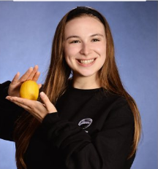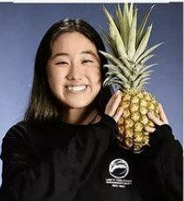
  - Event proposal form
    - Be sure to complete this form at least 2 weeks prior to the initial social media post that introduces your event :D
    - 1) LFSUS Event Proposal, submit to your VP and present during exec meeting
    - 2) Communications Request Form, submit to Della (VP Communications)
    - (optional) Sponsorships Request Form, fill out google form
    - (optional) Finance Reimbursement
  - Round 2.5 Hiring happening right now
    - Ends September 14th
    - Hiring for: Case Competition Coordinator, Partnerships & Student Benefits Coordinator, Graphic Designer, Photographer, Social Media Coordinator, Graduation Coordinator, EDI Subcommittee Coordinator
- 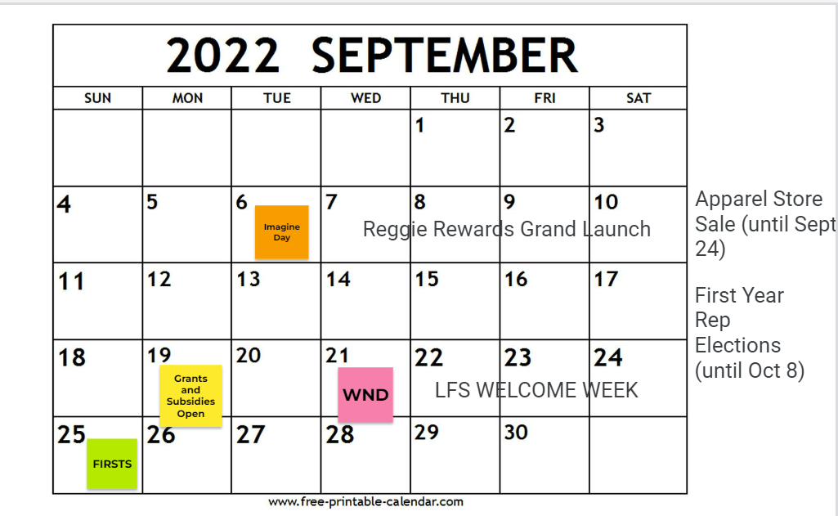
- VP Academic
  - HEWE
    - Mindfulness Monday Yoga with Student Life – Sept 19th @ AMS Nest 2301
    - Bunnies for HEWE event happening POTENTIALLY
  - Program Reps
    - No Updates
- VP Administration
  - Email Signature Setup
    - https://www.hubspot.com/email-signature-generator
    - I.e:
    - Text Fields:
      - Job Title: “_______ of the Land & Food Systems Undergraduate Society (LFS|US)”
      - Company Name: “The University of British Columbia xʷməθkʷəy̓əm(Musqueam) Territory”
      - Address: “Macmillian, 2357 Main Mall, Vancouver, BC V6T 1Z4”
    - For the logo, place this URL in: https://drive.google.com/file/d/1DDhpxVaZJp9xoMfd6sxzfAmrwAYWu57K/view?usp=sharing
    - Press “Create Signature” -> “Copy Signature” -> Go to your LFSUS Gmail -> Settings Icon -> “See all settings” -> “Add Signature” -> Paste signature in -> Delete “Create your own free signature”.
  - Training
    - Everyone should have finished the LFS Management Training System by now.
    - Community building education (CBE) training to be finished by September 14
  - Lounge & Apparel
    - Back to school sale sept 7 – sept 24
    - Opening the pod sept 27
    - Cleanliness of the office and pod
  - Governance
    - Fall election: First Year Representatives
Nomination form ready to launch and opens sept 13-sept 23 --> link https://ubc.ca1.qualtrics.com/jfe/form/SV_7UGHCMjgDhjkY4u
    - Campaigning starts sept 27
    - Voting period oct 4 - oct 7
    - Results will be announced to exec council on October 8th
    - Results announced to general council on October 10th
- VP Communications
  - FOLLOW @lfsusubc on Instagram and TikTok
  - “Land and Food Systems Undergraduate Society (LFS|US)” on Facebook
    - The above are where all promotions will turn up.
  - Communications Request Form
    - Click the link above or General> Council Forms > Communications Request Form Template
      - Instructions for what needs to be filled in can be found on the communications request forms.
    - Once you have filled it in; create a group-chat on teams with me and Clair (AVP) and send us the filled in form.
    - Submit 2 WEEK IN ADVANCE
    - **if your portfolio sends 3 late requests --> you most likely will have to create your own graphics & captions
      - The promotional material will likely be uploaded late.
  - First Year Rep marketing will start this week! Make sure you promote to any first years you know!
    - Nomination forms are going to be up this week.
  - Potentially having Grants and Subsidies post end of the week
  - Welcome Week was posted --> Share with your friends!!!
  - If your event isn’t finalized 2 weeks in advance, still send a comms request form in so that a template can be created.
- VP Engagement
  - EDI:
    - Creating updated EDI section of the LFSUS Event Proposal: criteria checklist and reflection question to be updated by end of September, as well as foundations of EDI Considerations Resource Guide to give council support in mindful event planning
    - Meeting end of month with LFS EDI Staff to get feedback on criteria and considerations guide
    - Meeting with AUS E&I team early October to share our progress on these projects
    - Please reach out to lfsus.vpengagement@gmail.com if you have any concerns/feedback!!
  - Sustainability
    - Creating updated Sustainability section of the LFSUS Event Proposal: criteria checklist and reflection question to be updated by end of September, as well as foundations of Sustainability Considerations Resource Guide to give council support in mindful event planning
    - Meeting with AUS VP Internal end of month to get feedback on our criteria.
    - Note: both subcommittees will take on more consultation work this year! Feel free to send your event proposals to me, or my sustainability and EDI coordinators when submitting your event proposals if you’d like feedback on your event from sustainability and EDI perspectives
  - WND
    - Our first WND is next week, September 21st, Reggie the Bee themed
    - Cowboy Caviar, Jackfruit Tacos, and sponsored Mango Coconut Sticky Rice Ice Cream from Elephant Garden Creamery (YUM!)
    - Our first WND will be FREE for first year and transfer students (Volunteers too), $4 for all other participants
    - We need volunteers, open to first years to! Please check out this link if you’re interested or contact lfsus.wndvolunteer@gmail.com : https://docs.google.com/forms/d/e/1FAIpQLSfzYBzHErtbWfr2DK4c_fSgBaF_6q7IwfNx6JjH4gkL6r4O9A/viewform
    - Check out our posts on social media for more details on WNDs and volunteering!
- VP External
  - Clubs
    - Hopefully gaining some new clubs under our jurisdiction!
    - We are currently meeting with the clubs under our jurisdiction to see what they wish to see from the LFS|US
    - If you wish to collab with clubs connect with Sofia or Sara
  - Case Competition
    - Working on potential prompts for case comp, finalized a theme.
    - List of judges created
  - Partnerships & Student Benefits
    - Launched Reggie Rewards on Imagine Day. Ran out of reggie rewards cards!
    - Ordering more, but be on the look out for future updates (:
    - Please try to fill out sponsorship form 1 month in advance!!
      - Will be included in the event proposal form (Keep in mind this is 2 weeks in advance, but the sponsorship section should be sent in 1 month in advance..
      - If unable to secure sponsorship, remember we do already have some benefits from reggie rewards
    - If you want to partner with a certain businesses please reach out to partnerships.
- VP Finance
  - New role in Finance portfolio – Financial Coordinator
    - Erin will be supporting portfolios in wisely planning budgets to ensure that events are budgeted reasonably
    - In the event proposal form, there is a part that you need to fill if you are using your budget, please contact Erin at lfsus.financialcoordinator@gmail.com and cc me at lfsus.vpfinance@gmail.com with the date of your budget meeting so we could sit in and help with budgeting
Reimbursement process
https://docs.google.com/presentation/d/1sPtIIWgR88zyz-Qq_LAzuyz-djAV-0u8pHckCq3zUa4/edit?usp=sharing
  - Grants and Subsidies program will start soon, exact date not set yet, details such as criteria as below
https://ubcca.sharepoint.com/:w:/r/teams/ubcst-gr-LFSUS/Shared%20Documents/Finance/2022-2023/LFSUS-2022-2023-Grants%20Criteria%20Package.docx?d=w618fafeb087848a7a94bfaf7a042fb61&csf=1&web=1&e=skihGx
- VP Internal
  - No Updates
  - First Year Committee
    - No updates
- VP Student Life \\\\
  - VP Student Life + AVPS
    - Imagine Day Complete!
      - Thank you all for your help 💗
    - Welcome Week is Sept. 19-25 (Please volunteer! Reach out to student life.)
      - Mindfulness Monday Yoga
        - Collab w/ UBC Yoga + HeWe
        - DoMatcha Set Giveaway!
        - Will take place in the Nest
      - Flower Pressing Tuesday
        - Looking to secure Herbaland snacks.
        - UBC Jazz!
        - Collaborating with Roots of the roof (Roof tour)
          - Bring flowers or use the flowers provided.
        - Please reach out if you have snack recommendations.
      - WND
        - Free to first year, transfer students and volunteers!
        - Reggie themed photo-op
        - Table games/icebreakers.
        - Someone volunteer for Reggie?
      - Thrift Swap Thursday
        - Clothing, accessories, appliances (Working/functional)
        - Canned food will go to AMS Food Bank!
        - Feel free to start dropping off items during Executive Office Hours! (Or contact Colette directly)
        - Donations may also go to Wish or UBC Thrift.
      - Funky Art Friday
        - Tie-dye and acrylic painting!
        - White shirts/socks will be provided, paints and music provided.
      - Homecoming Programming
        - Put on by student services
        - Games, AWP programming, Alumni Networking
        - Agora 1:30pm-3:30pm
        - Animal welfare program will be displaying research.
        - Alumni will be there.
      - LFS Firsts
    - Interfaculty Cup
      - Planning taking place.
      - Competition between all the faculties.
      - Thinking of sustainability/green event partnered with FUS.
  - Annual Events
    - Gala is set for March 10, 2023!
    - LFS Week is set for Jan 23-27
  - Socials
    - FUS x LFSUS Soccer Game
    - Planning this year’s Carnival!
- Senior Advisor
  - No updates <3
- AMS Representative
  - AMS hired Elections Administrator Ashley Haines
    - EA will oversee the September by-election for the VP Finance who resigned and by-elections held by Constituencies (like us)
  - AMS Services presentation on Strategies and Goals
    - https://www.ams.ubc.ca/wp-content/uploads/2022/08/22-23-AMS-Services-Strategies-and-Goals-Presentation-for-AMS-Council-A....pdf
- Student Senator
  - No updates <3

ACTION ITEMS
- @all Read Transition Report & Login to Email
- @all Complete the Community Building Education
- @all Complete & upload “Getting to know you” responses by next meeting
- @all Volunteer for WNDs and Welcome Week!

MEETING ADJOURNMENT AT 6:02 PM

